Senior Design: LoRa Documentation

Mini Project description: Using Arduino, design sender and receiver modules for esp32 LoRa Wifi chip.

Design setup:

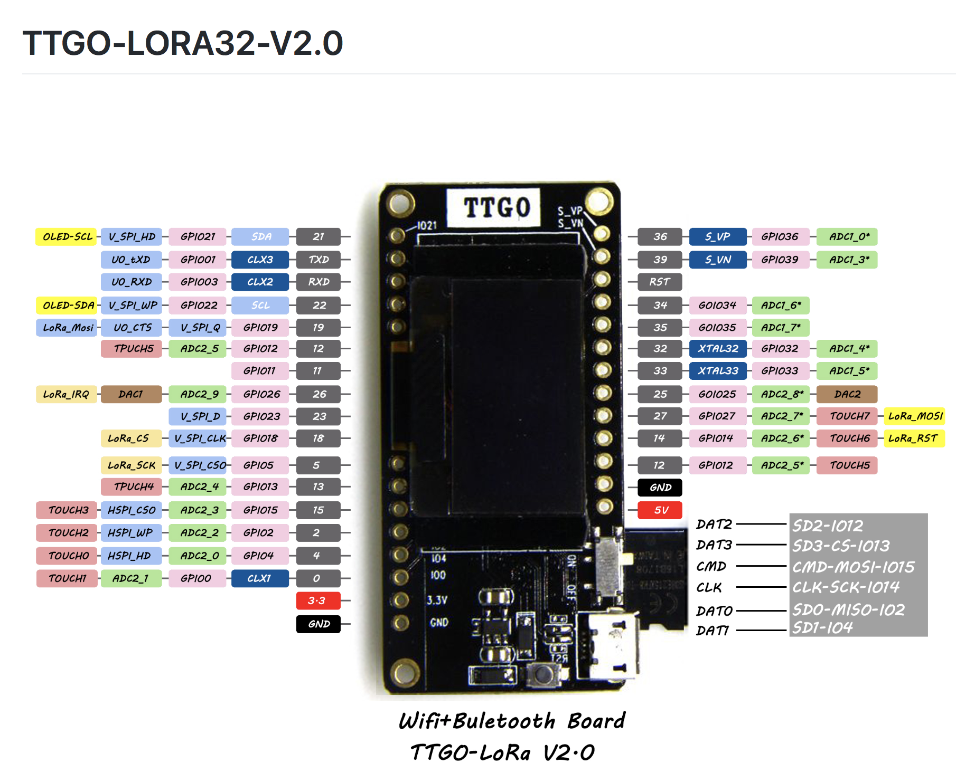

Figure 1 – LoRa Board interface Ports

Procedure:

1. Download and install Arduino IDE 1.8.5
2. Download and install Arduino Core for ESP32 Wi-Fi chip (<https://github.com/espressif/arduino-esp32/blob/master/README.md>)
3. Initial code used for receiving and transmitting: <https://github.com/LilyGO/TTGO-LORA32-V2.0>
4. Search and include libraries that are unrecognized (LoRa.h, SSD1306.h, images.h)
5. Install SiLabsUSBDriver for USB to UART interface (Mac OSX)
6. Make appropriate changes to the code, compile, and upload.

Results:

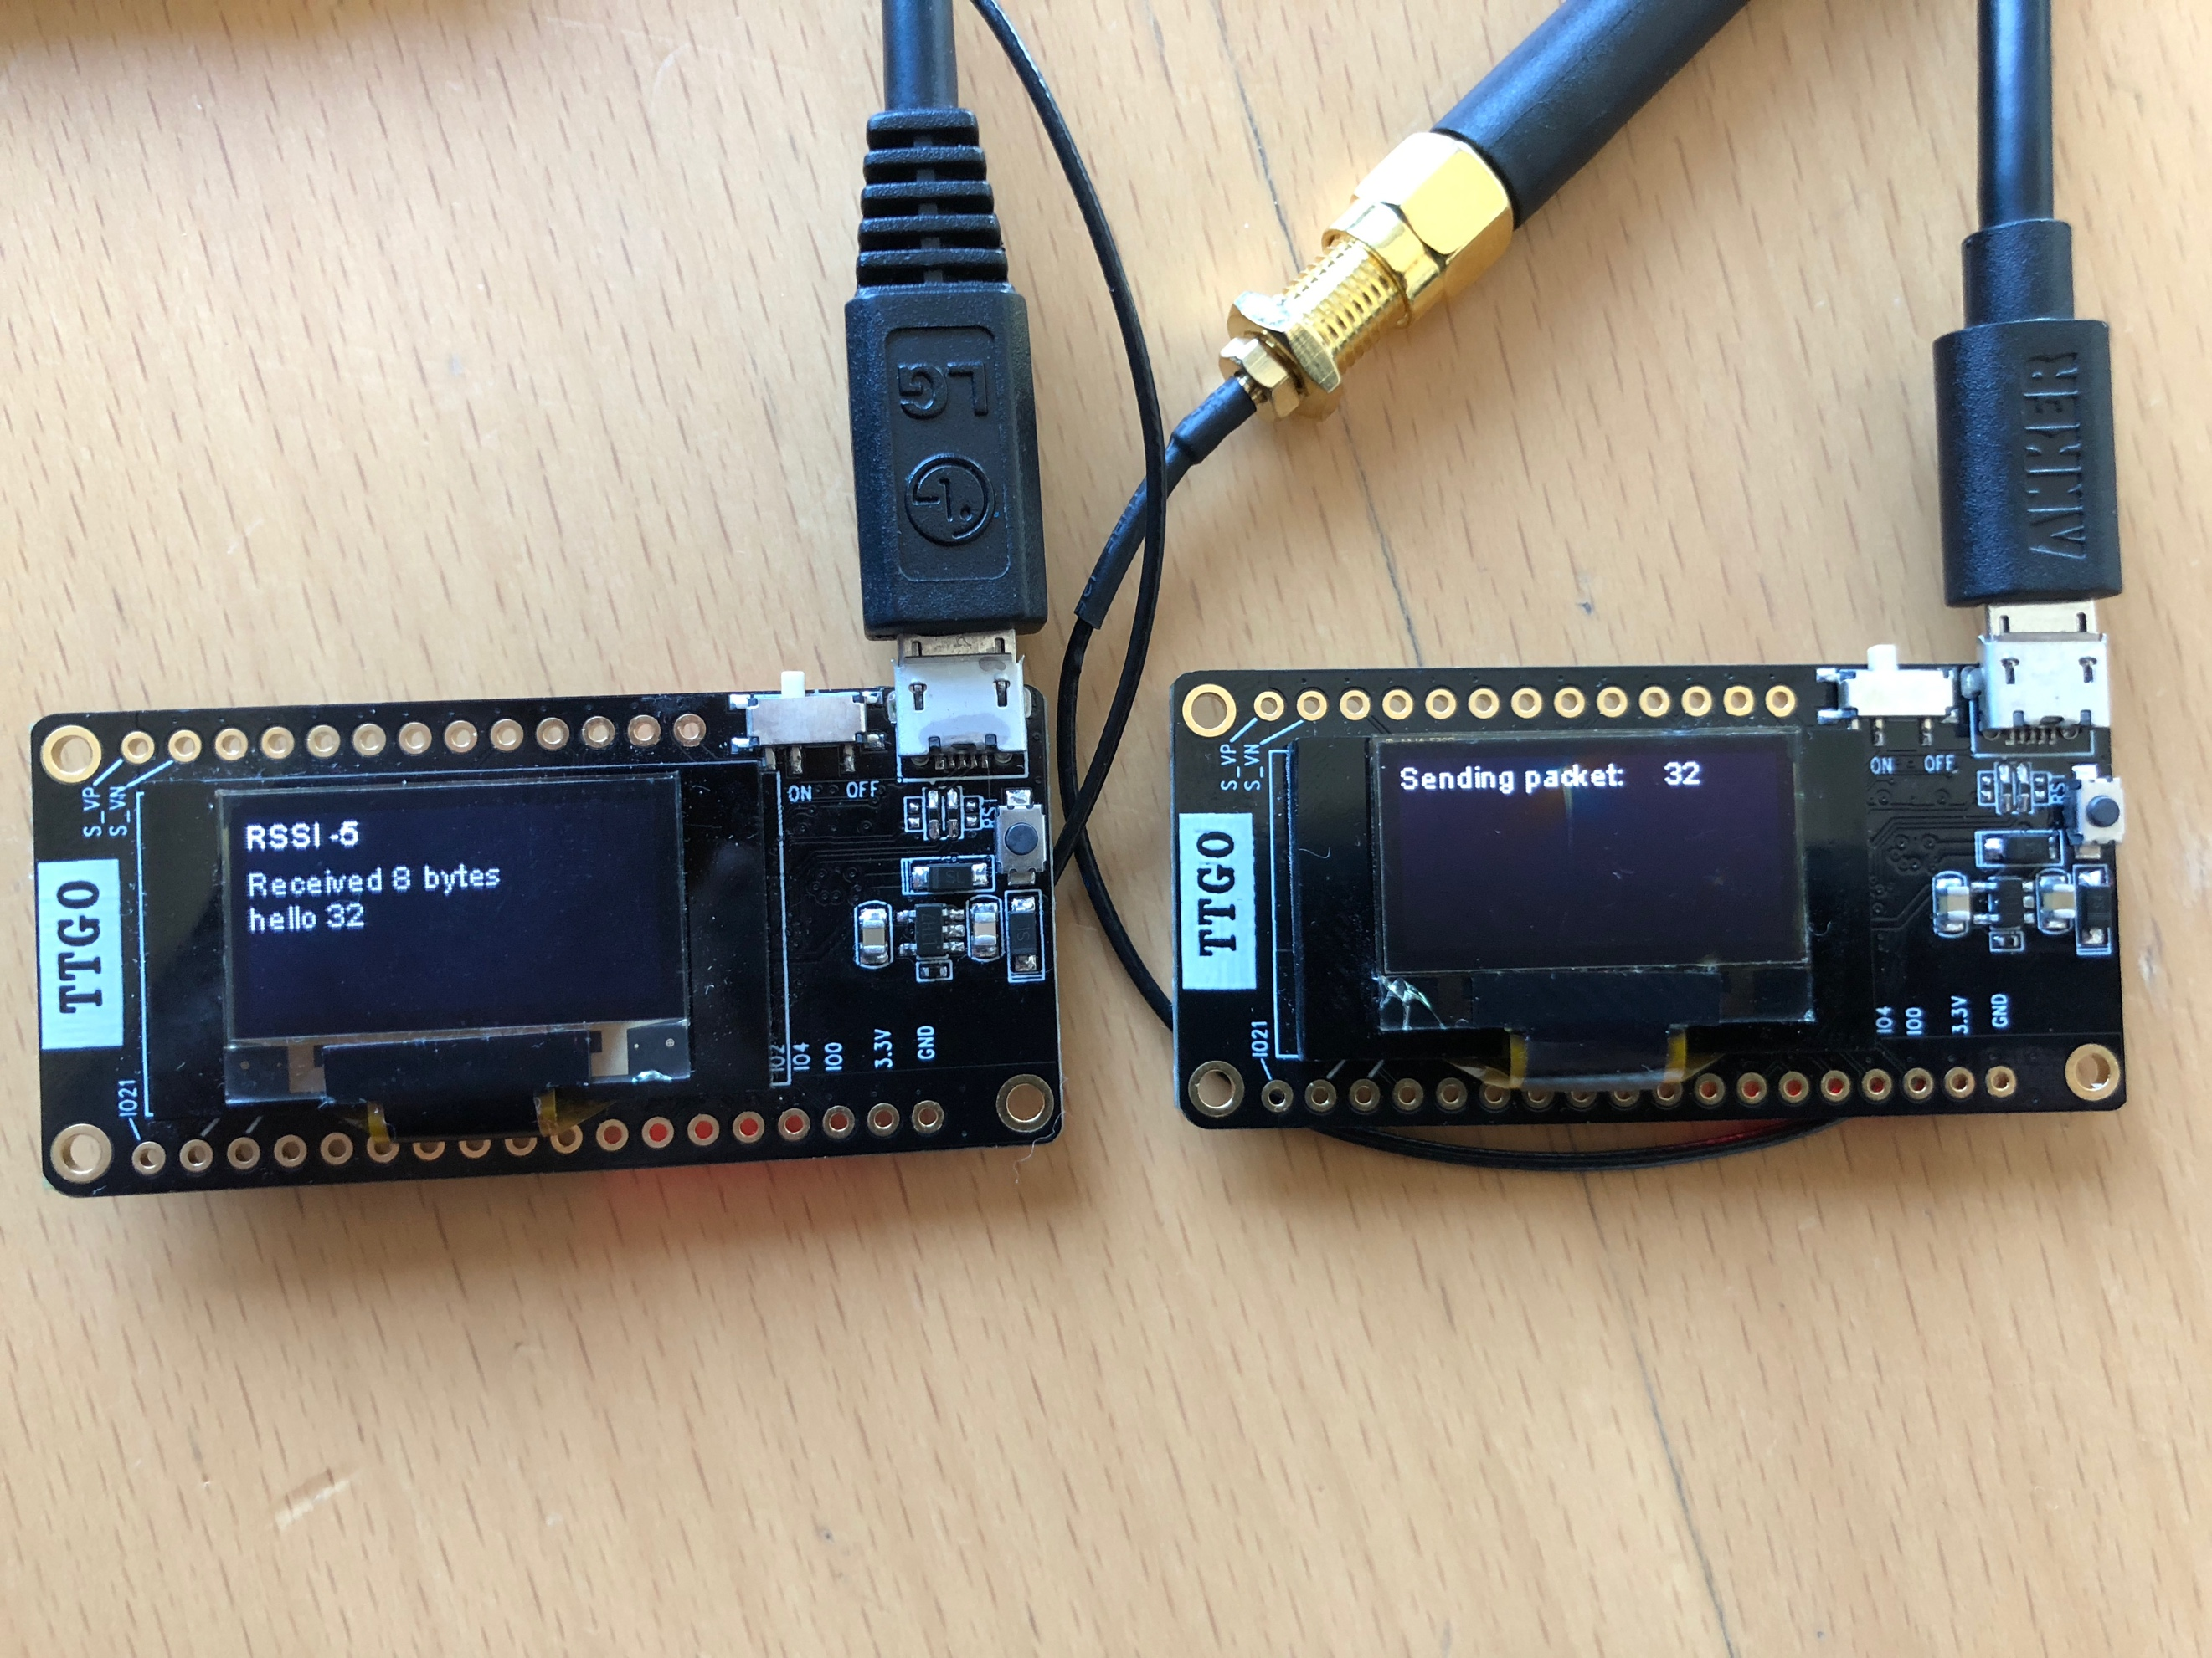

Figure 2 – Receiver and Sender LoRa Wifi Chips Communicating

Sending Senor Reading

Code:

<https://github.com/G6EJD/ESP32-DS18B20-Sensor-Reading/blob/master/ESP32_DS18B20.ino>

SD card code:

<https://github.com/nhatuan84/esp32-micro-sdcard>